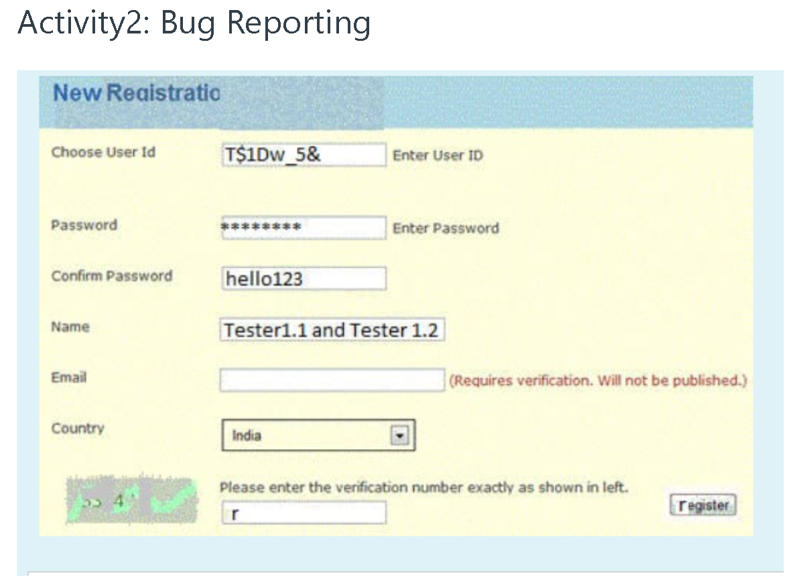
Bug Report

Bug ID | Subject | Description
BG01 | Bug on user ID | User id feild should allow user to enter numeric values only
BG02 | Bug on Confirm Password | Password must not be visible
BG03 | Bug on Name feild | Name should not allow user to enter numeric value and symbol
BG04 | Bug on verification number | Verification number should be clearly visible
BG05 | Bug on register button’s | First character is highlighted on button
BG06 | Bug on Email feild | Email feild should be set as an mandatory feild
BG07 | Spelling of Registration | Spelling should be correct from  New Reaistratio to New Registration.
BG08

